Домашнее задание

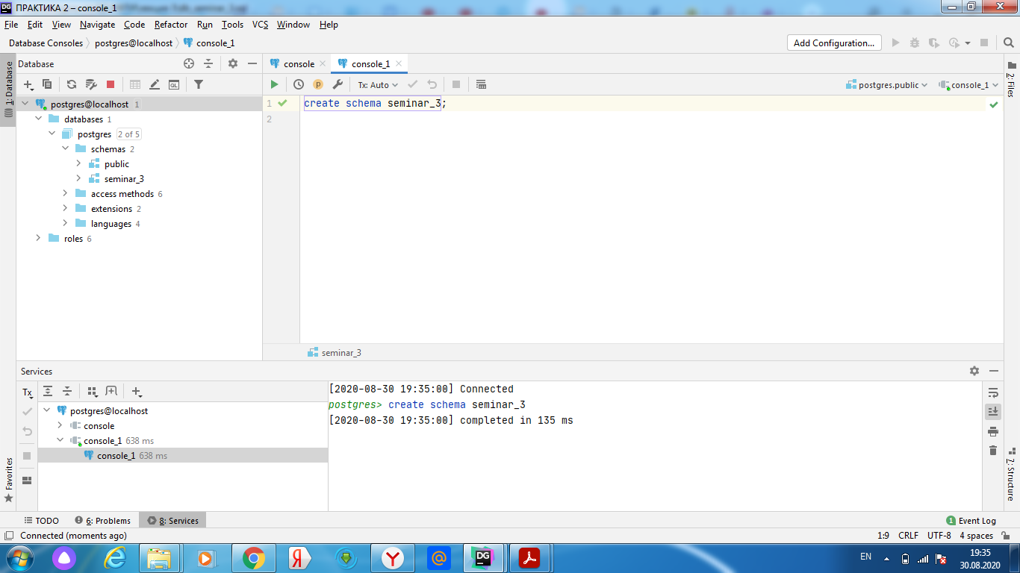

Рисунок 1

По лекции

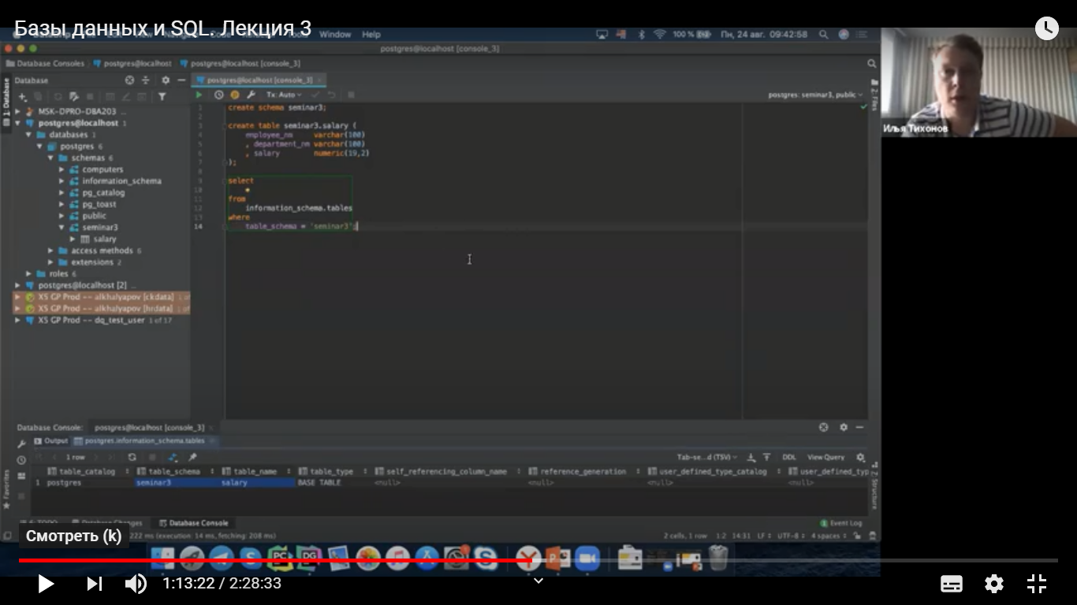

Рисунок 2

3 1

create schema seminar_3;  
create table seminar_3.salary(  
 employee_nm varchar(100)  
 ,department_nm varchar(100)  
 ,salary numeric(19,2)  
);

з 2  
select  
 *\**from  
 information_schema.tables  
where  
 table_schema='seminar_3';

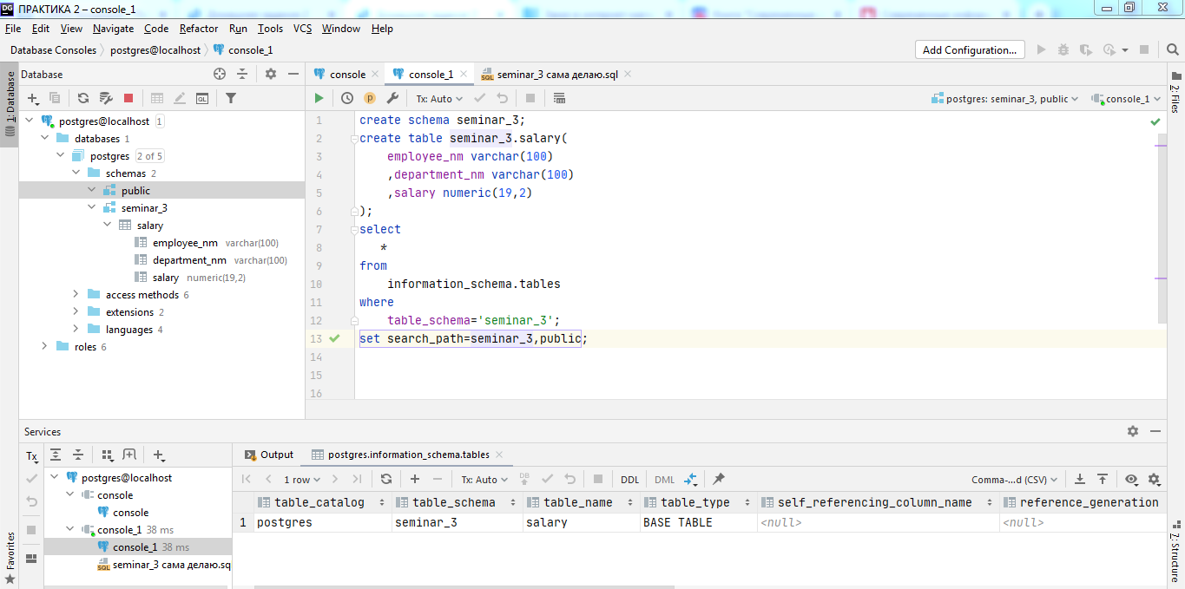

Рисунок 3

З _3

insert into salary values('IVANOV IVAN','HR',500);  
insert into salary values('PETROV ANDREJ','HR',400);  
insert into salary values('DEMIDOV IVAN','PR',350);  
insert into salary values('PETROV ANDREJ','SUPPORT',300);  
insert into salary values('DEMIDOV IVAN','SR',650);

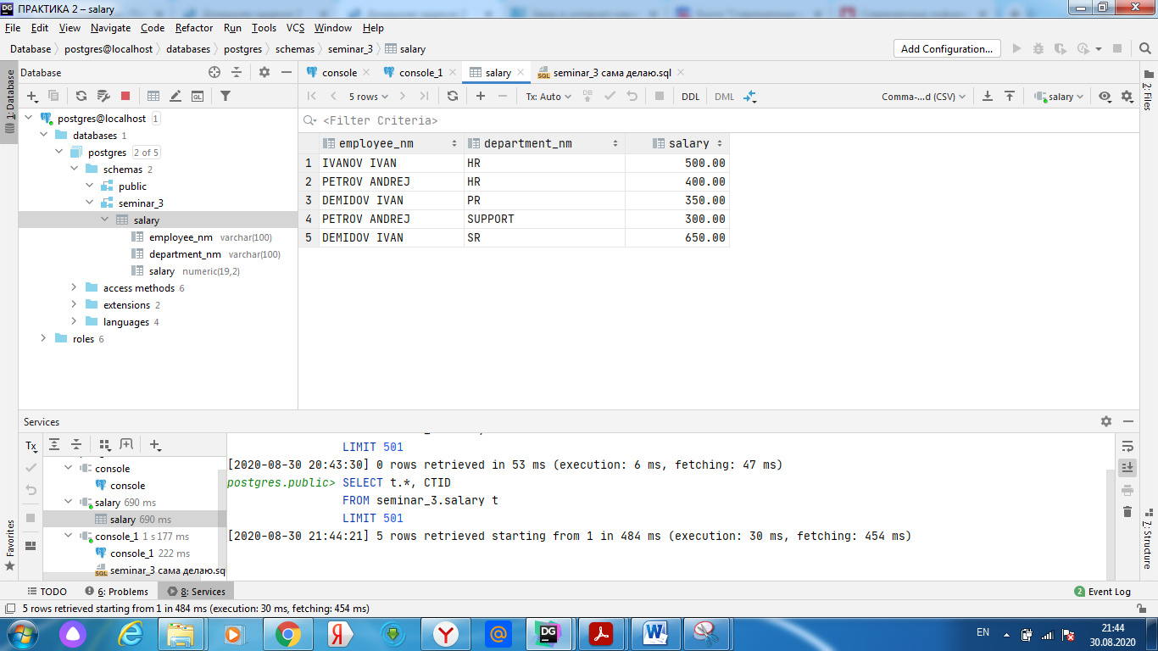

Рисунок 4

*--4*ALTER TABLE salary ADD COLUMN comment varchar(100);  
*--5*UPDATE salary  
SET comment = 'programmist'  
WHERE department_nm = 'HR';  
UPDATE salary  
SET comment = 'administrator'  
WHERE department_nm = 'SUPPORT';  
UPDATE salary  
SET comment = 'director'  
WHERE department_nm = 'SR';  
UPDATE salary  
SET comment = 'Pr-agent'  
WHERE department_nm = 'PR';

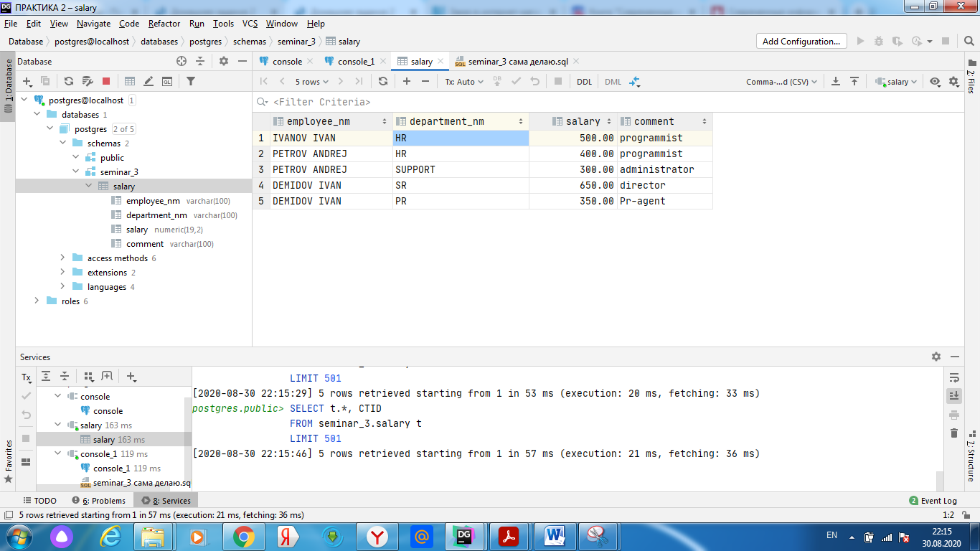

Рисунок 5

--6

DELETE FROM salary  
where department_nm = 'PR';

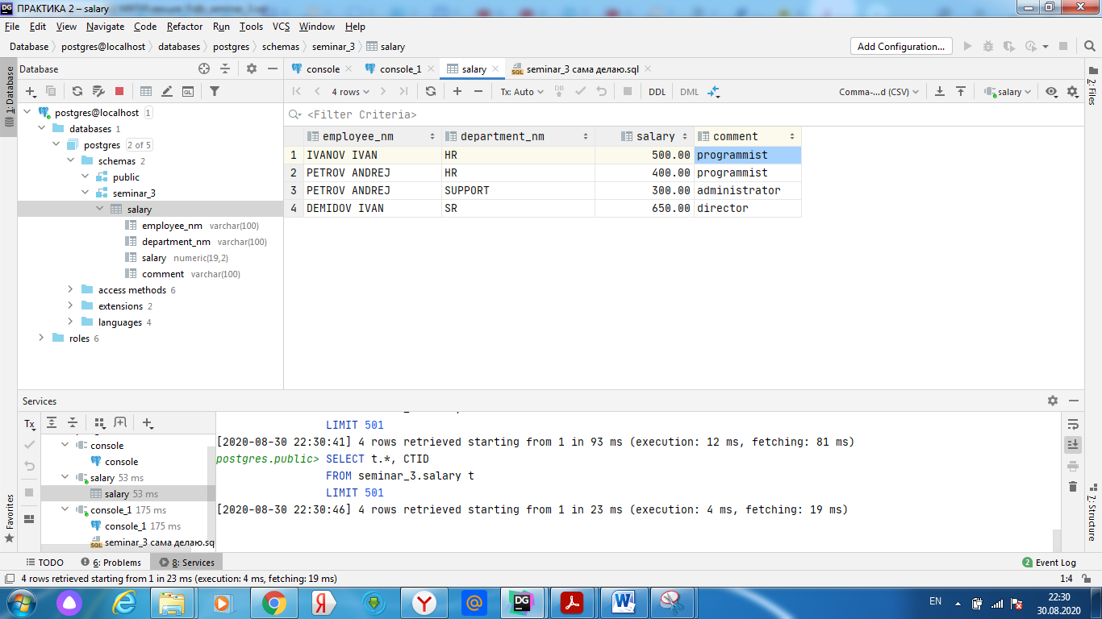

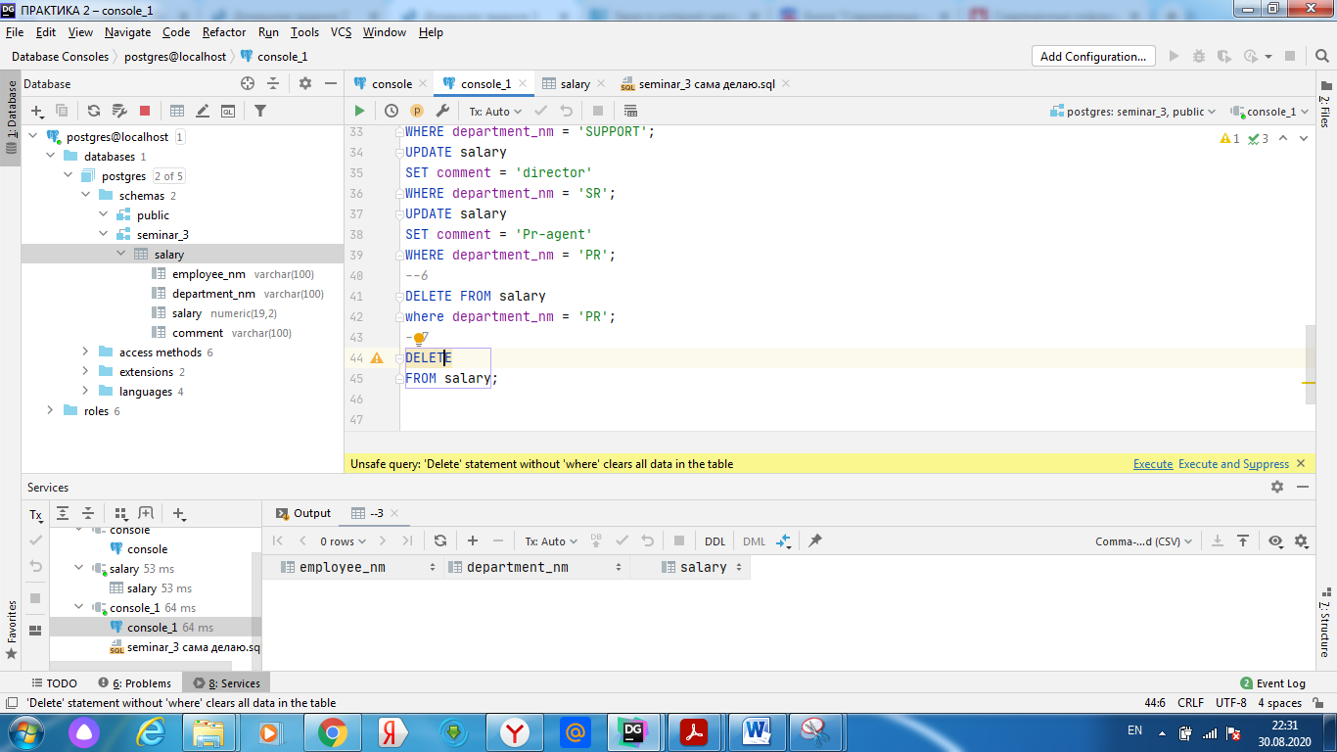

Надо нажать: execute

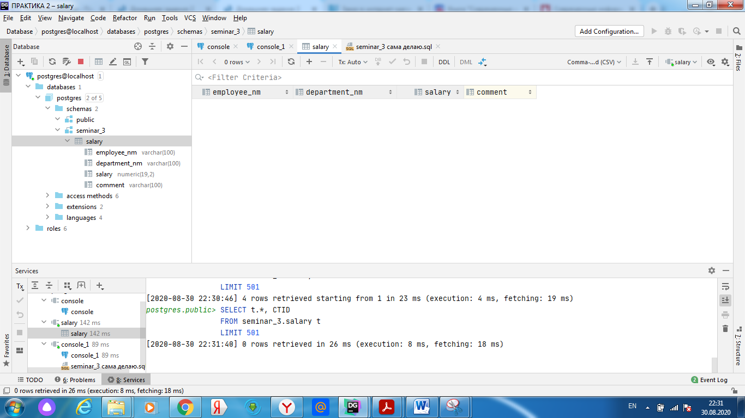

Данные таблицы удалены

*--7*DELETE  
FROM salary;

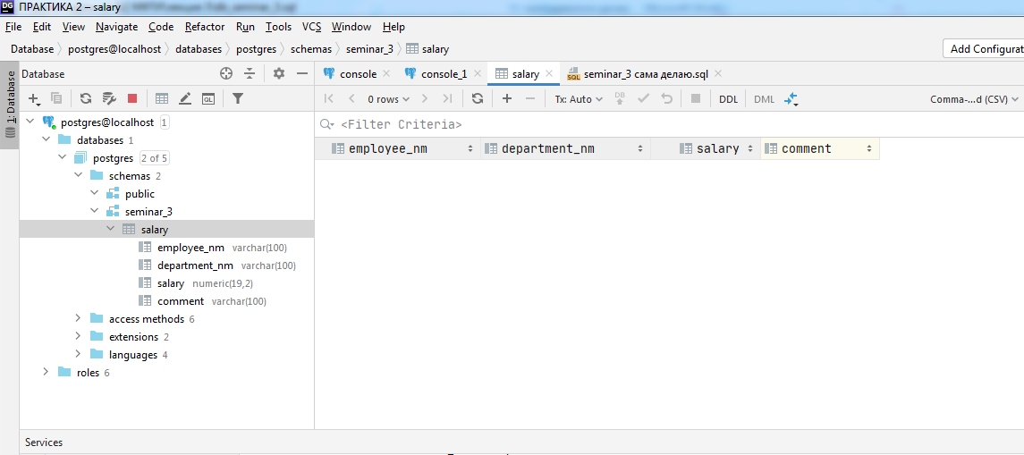

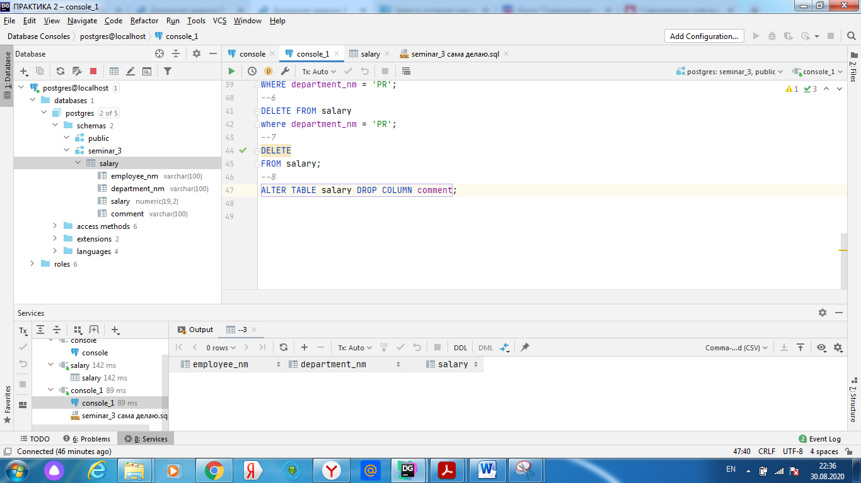

*--8*ALTER TABLE salary DROP COLUMN comment;

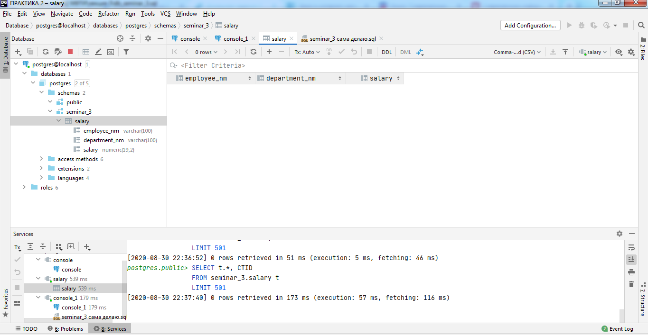

--9

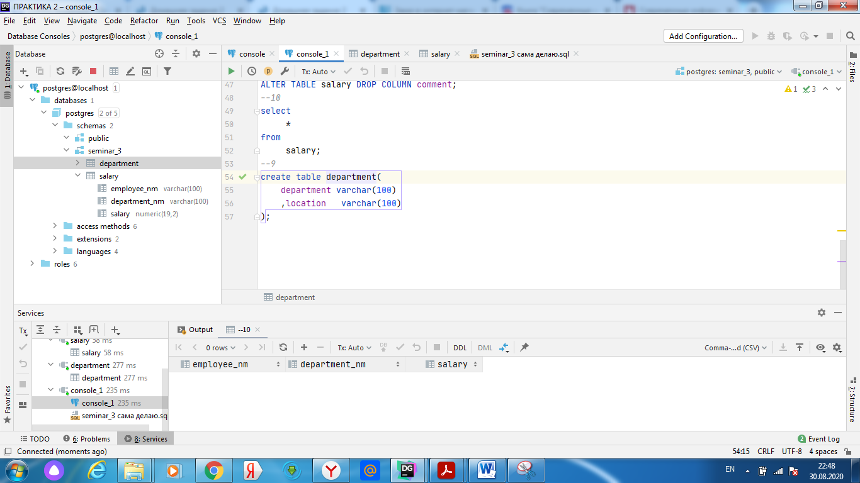

create table department(  
 department varchar(100)  
 ,location varchar(100)  
);

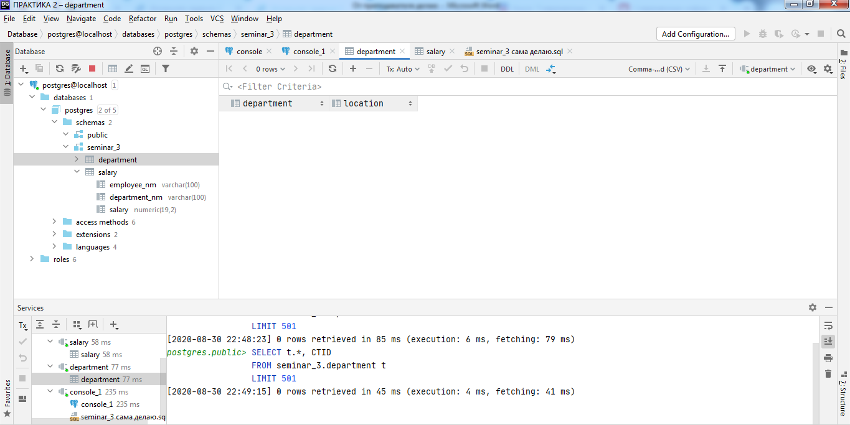

*--10*select  
 *\**from  
 salary;

select  
 *\**from  
 department;

--11

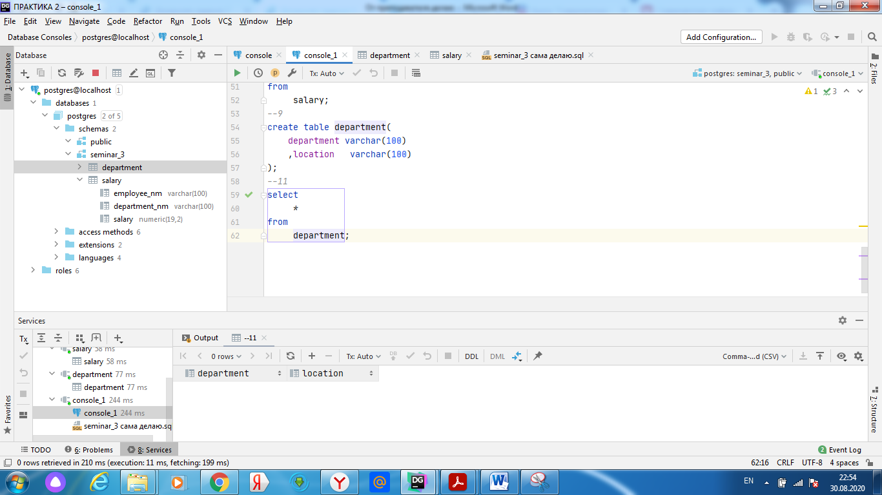

*--12*SELECT  
 *\**FROM salary  
WHERE  
 salary>500;

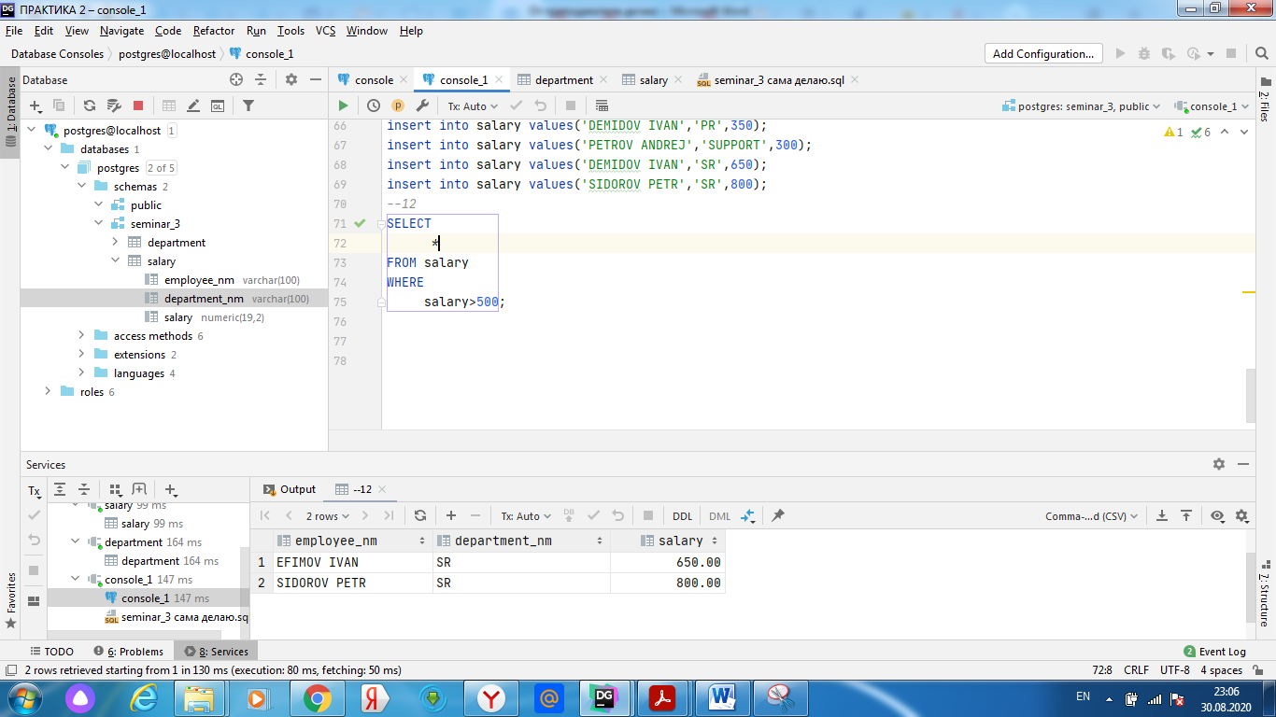

*--13*SELECT  
 *\**FROM salary  
WHERE  
 salary<400 and department_nm='HR';

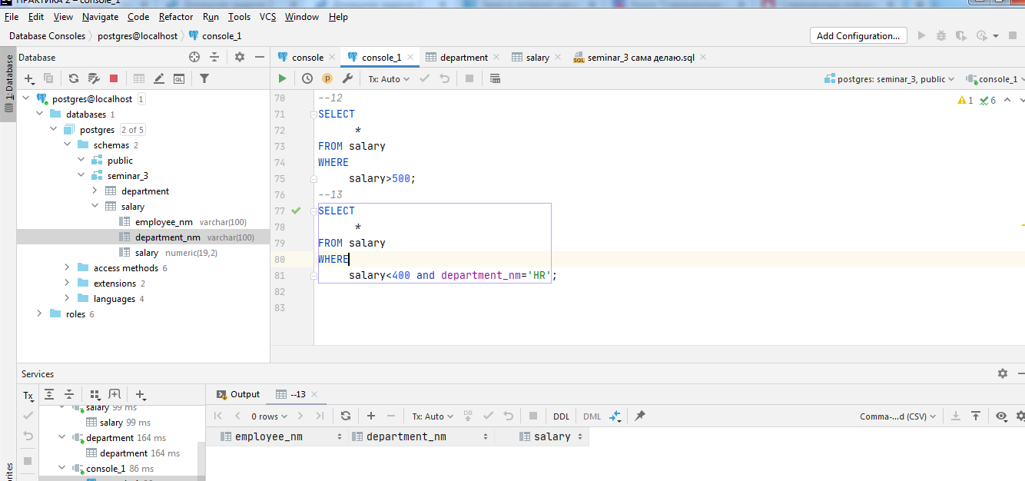

*-- ПОДГОТОВКА К ЗАДАНИЮ 14*insert into department values('HR','MOSCOW');  
insert into department values('PR','PITER');  
insert into department values('SR','');  
insert into department values('SUPPORT','STAVROPOL');

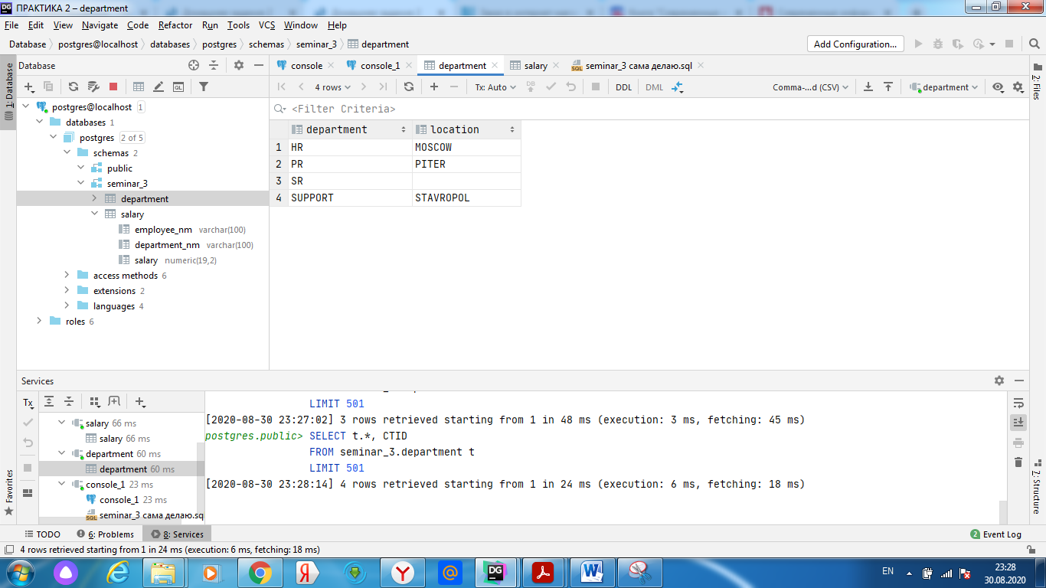

*--14*SELECT  
 employee_nm  
FROM salary as sl  
 inner join department as dp  
 on sl.department_nm=dp.department  
 and dp.location='MOSCOW';

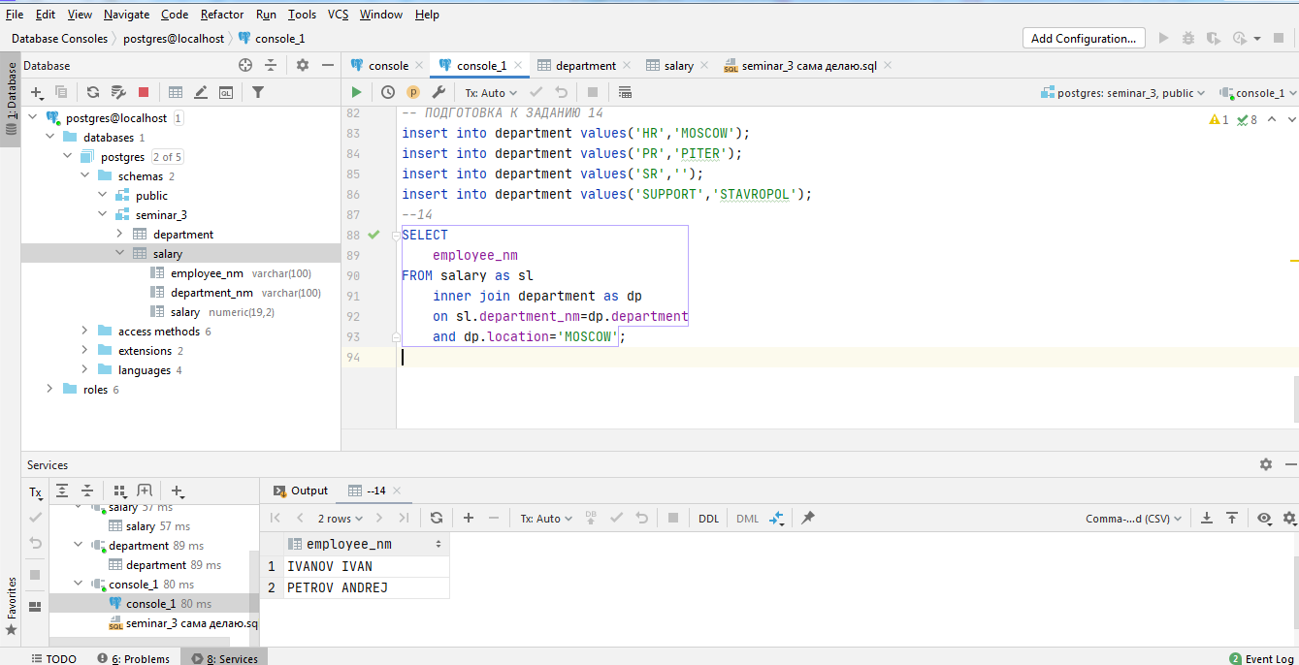

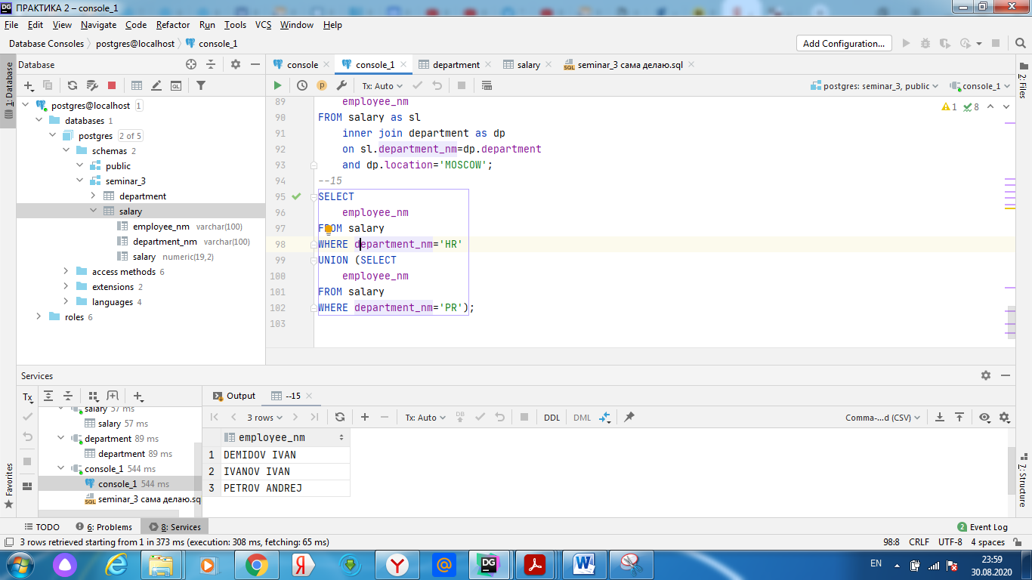

15

SELECT DISTINCT  
 employee_nm  
FROM salary  
WHERE department_nm='HR'  
UNION (SELECT  
 employee_nm  
FROM salary  
WHERE department_nm='PR');

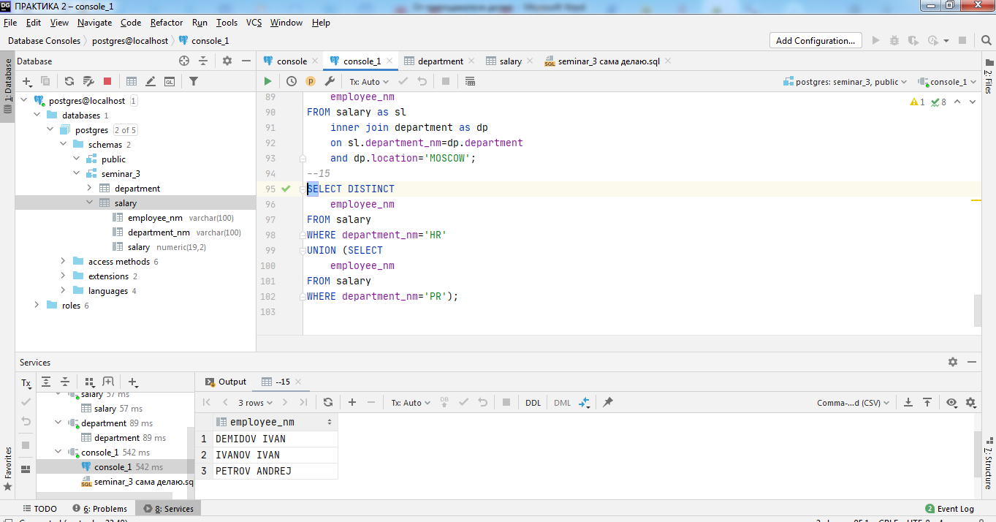

В SP ЗАПОЛНИЛА NULL

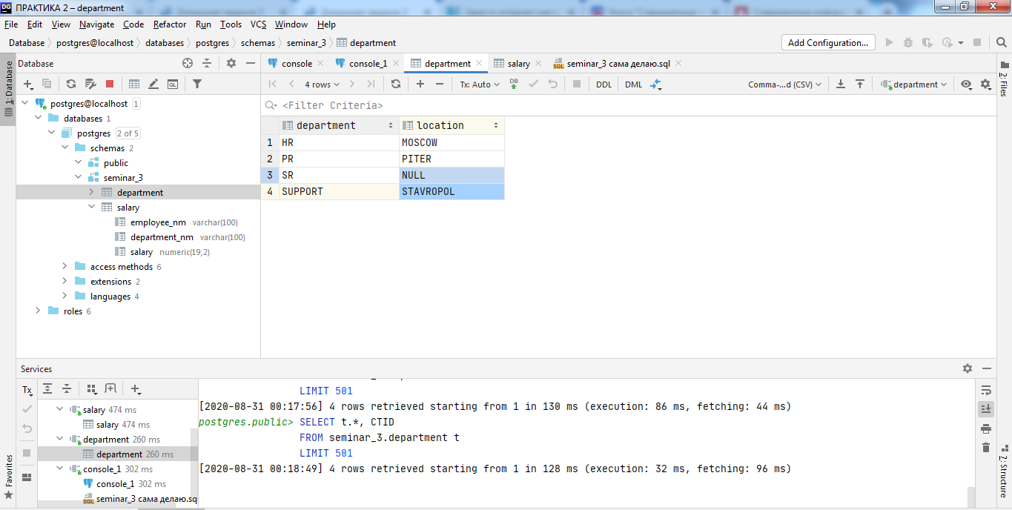

16

SELECT  
 *\**FROM salary as sl  
 INNER JOIN department as dp  
 on sl.department_nm=dp.department  
 and dp.location is NULL;

--17

SELECT *\**FROM department  
WHERE department LIKE '__';

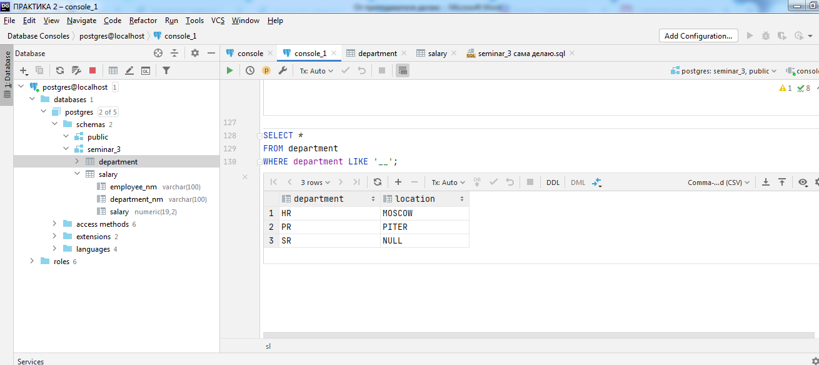

--18

SELECT *\**FROM department  
WHERE department LIKE 'S%';

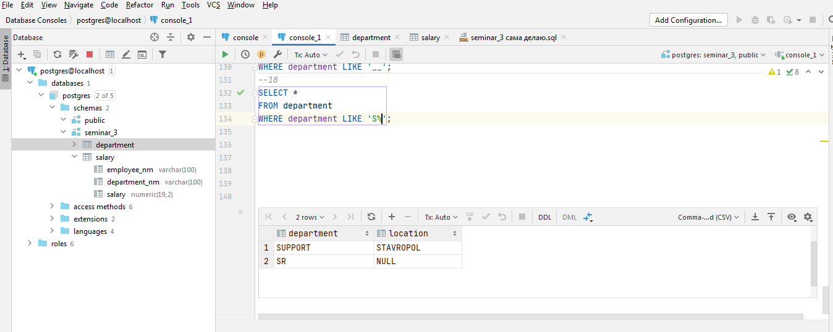

*--19*SELECT  
 employee_nm  
FROM salary  
WHERE NOT(department_nm='R&D')  
UNION (SELECT  
 employee_nm  
FROM salary  
WHERE NOT(department_nm='SUPPORT'));

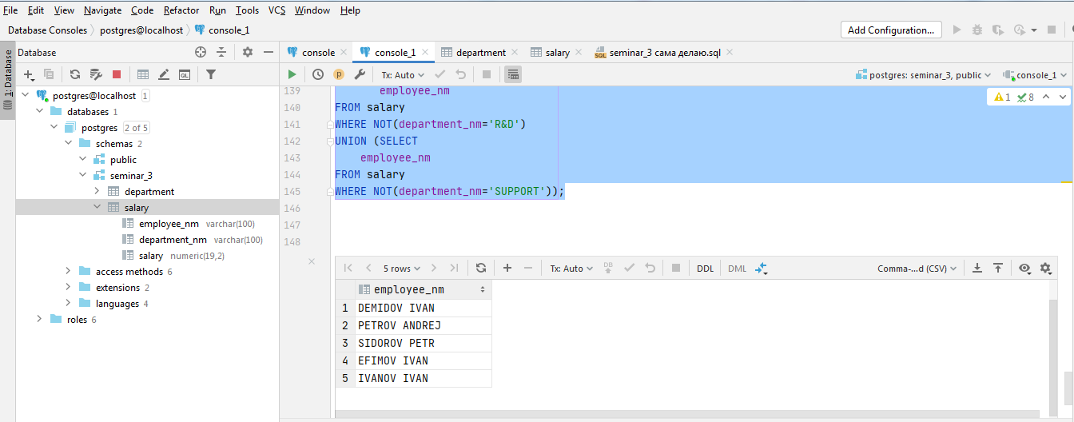

*--20*SELECT *\**FROM department  
WHERE department LIKE '%A%' AND department LIKE '%E%';

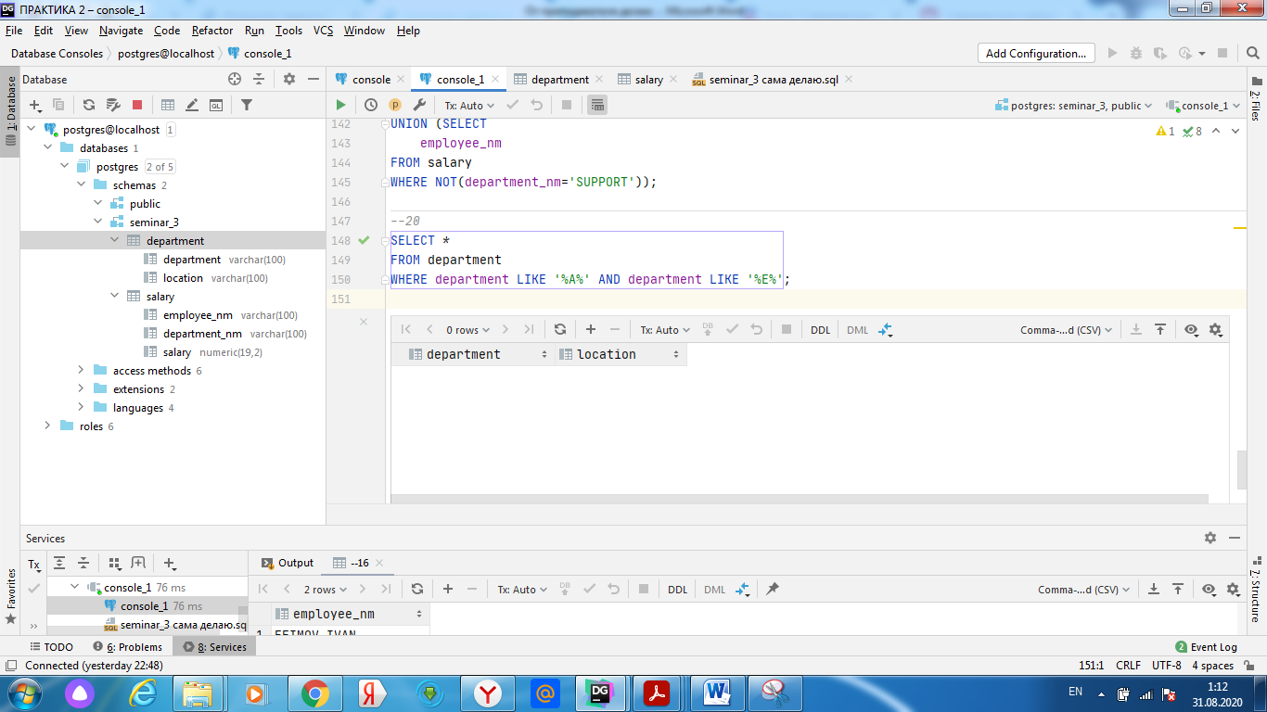

*--21*SELECT  
 *COUNT*(*\**)  
FROM salary;

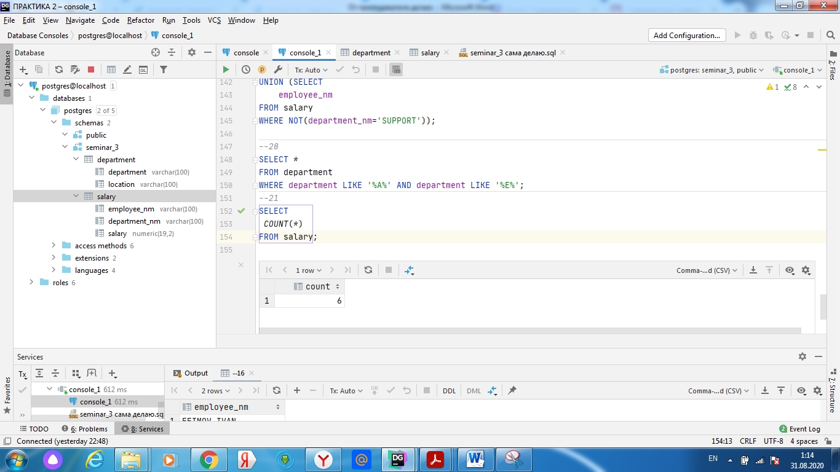

--22

SELECT  
 *max*(salary)  
 ,employee_nm  
FROM salary  
group by employee_nm;

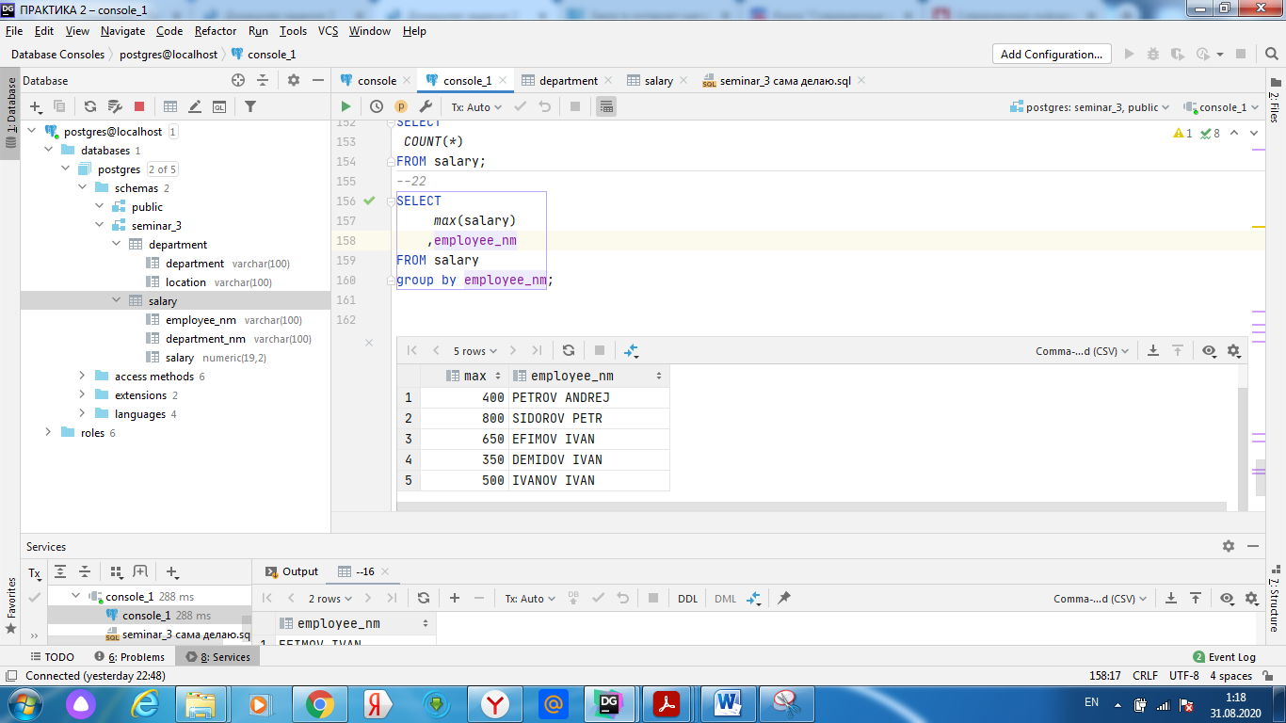

*--23*SELECT  
 *count*(employee_nm)  
 FROM salary  
where salary>500;

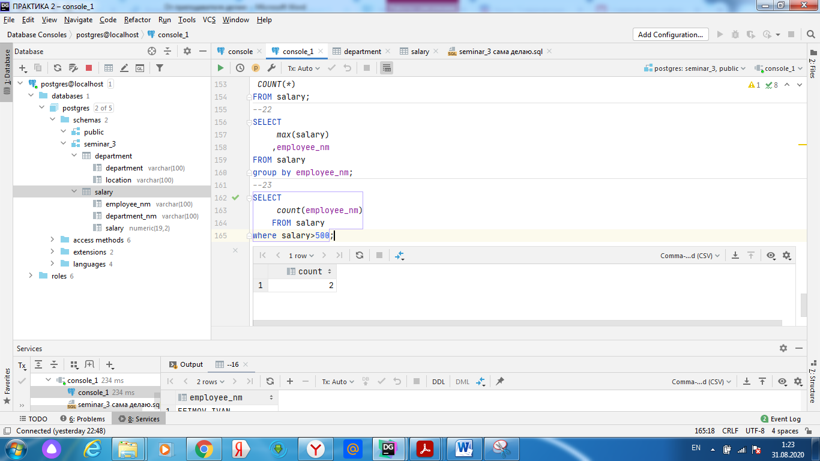

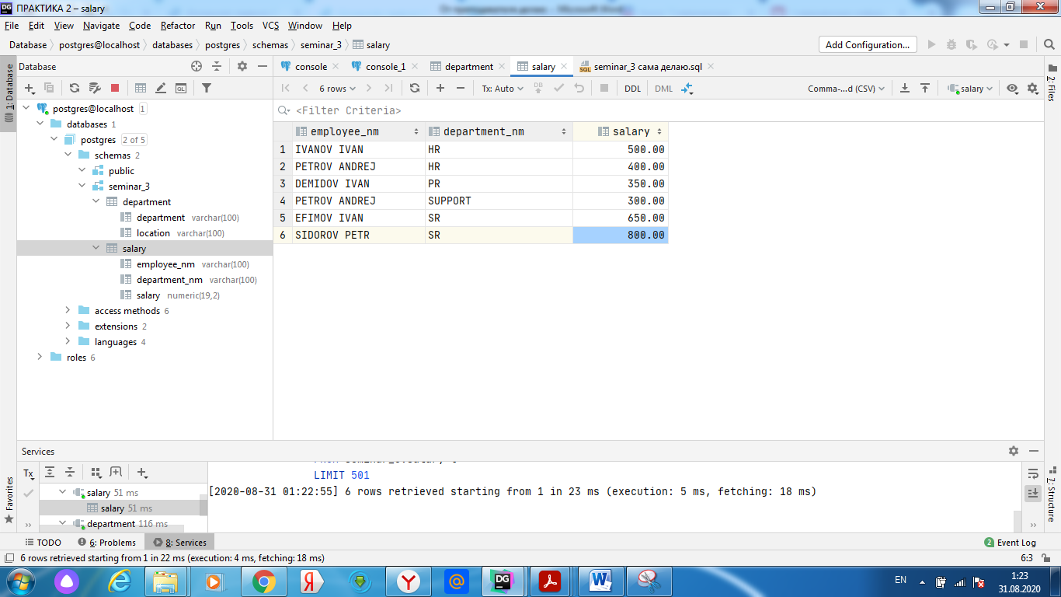

*--24*SELECT  
 department_nm,*avg*(salary)  
 FROM salary  
group by department_nm;

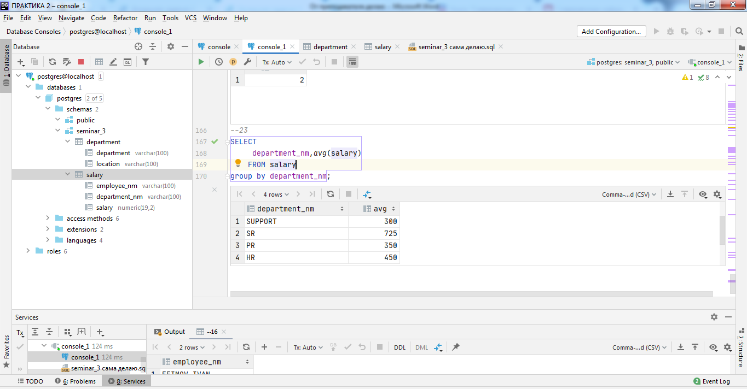

*--25*SELECT  
 *max*(salary),dp.location  
 FROM salary  
 inner join department as dp  
 on salary.department_nm=dp.department  
group by dp.location;

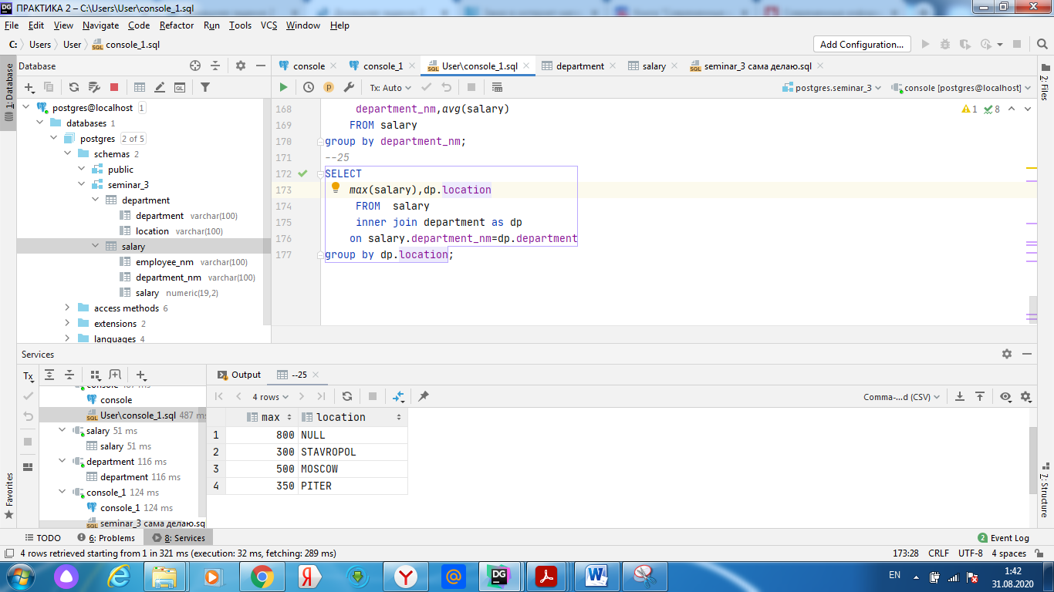

*--26*select distinct  
department_nm  
from salary  
group by department_nm  
having *count*(department_nm)>0;

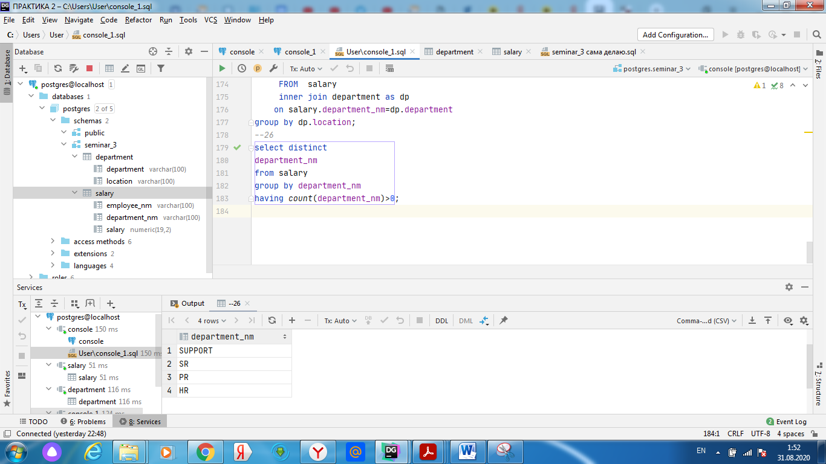

--26 2

select distinct  
department_nm  
from salary;

*--27*SELECT  
 *count*(employee_nm),dp.location  
 FROM salary  
 inner join department as dp  
 on salary.department_nm=dp.department  
 group by dp.location;

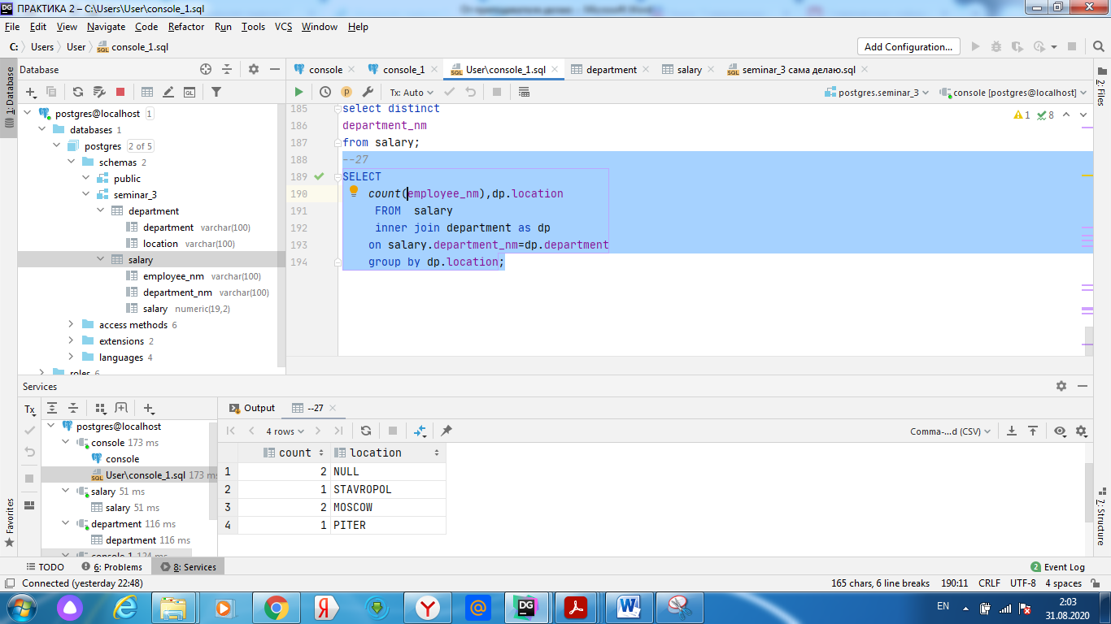

*--28*SELECT  
 department_nm  
 FROM salary  
group by department_nm  
having *avg*(salary)>300;

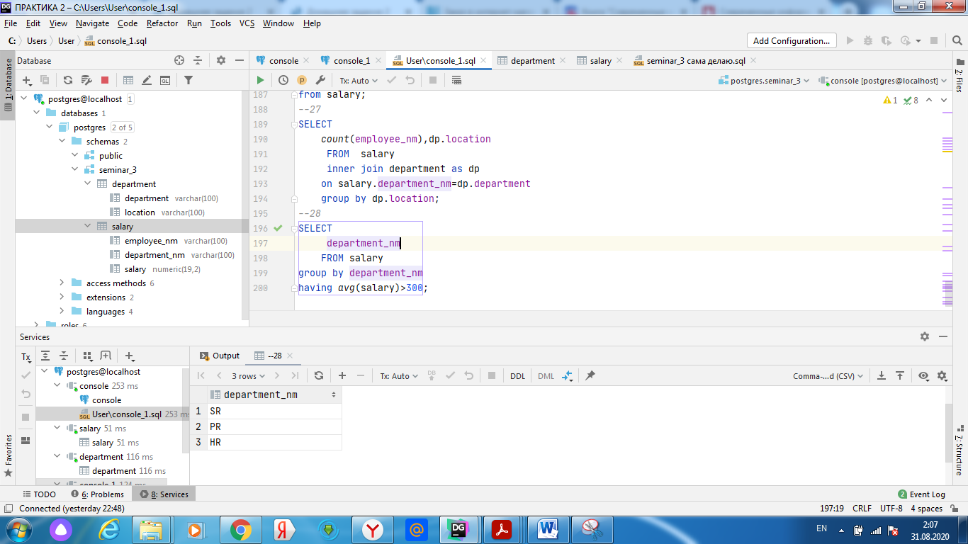

*--29*SELECT  
 dp.location,*min*(salary)  
 FROM salary  
 inner join department as dp  
 on salary.department_nm=dp.department  
 group by dp.location  
 having *min*(salary)>500;

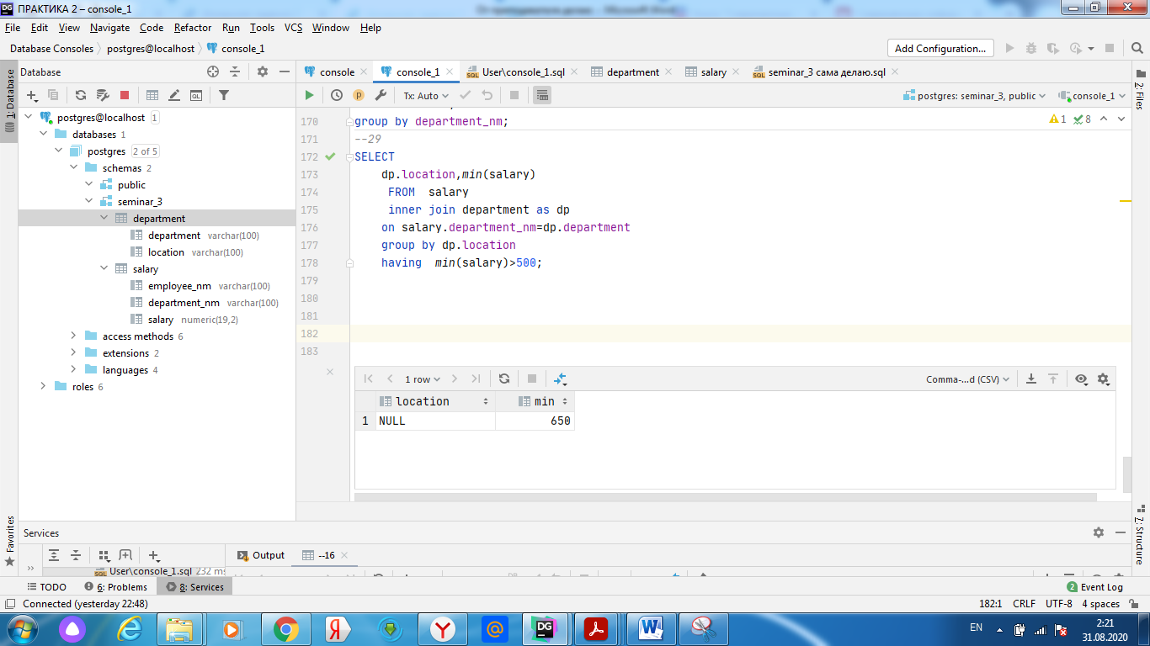

*--30*select distinct  
department_nm,*count*(employee_nm)  
from salary  
group by department_nm  
having *count*(employee_nm)>=10;

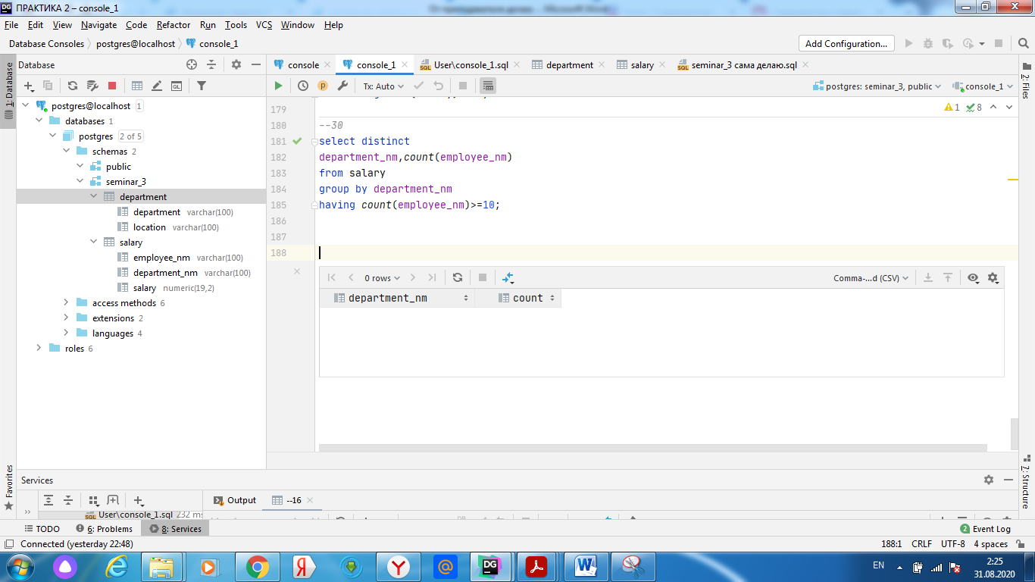

*--31*select *\**from salary  
order by salary desc;

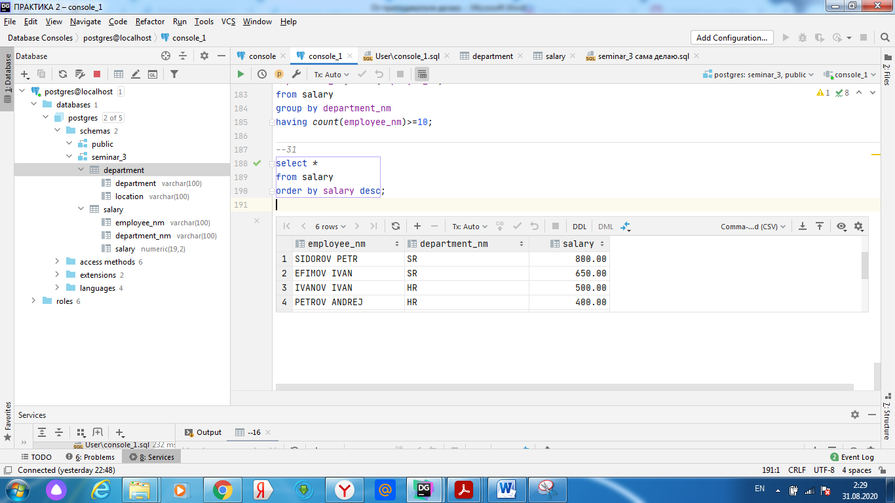

--32

*--32*SELECT  
 employee_nm,dp.location,salary  
 FROM salary  
 inner join department as dp  
 on salary.department_nm=dp.department  
 group by employee_nm,dp.location,salary  
 order by dp.location,salary;

